Curriculum Vite
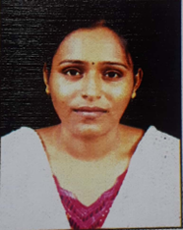
Name : Saswati Roy
Address: 1/1 College Ghat Road, B.Garden,
Howrah—711103
Contact Number: 09874768009
e-mail ID: saswatiroy2009@gmail.com
Gender: Female
Designation: SACT-I in the Department of Anthropology, Mrinalini Datta Mahavidyapith, Kolkata—700051
Highest Qualification: M.Sc. in Anthropology (from C.U.) on 2006,
Qualified UGC-NET-JUNE-2008

