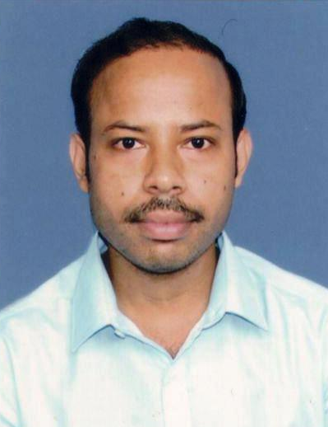
Dr. Chiranjit Patra
State Added College Teacher (SACT-1)
Department of Chemistry,
Mrinalini Datta Mahavidyapith,
Kolkata - 700051

Examination | Year | Board/University | Percentage |  | Division  /Class
Secondary  Examination | 2004 | West Bengal Board of Secondary Education | 78.75 |  | 1st Divn
Higher Secondary  Examination | 2006 | West Bengal Council of Higher Secondary Education | 82.6 |  | 1st Divn
Bachelor of Science in Chemistry (Honours) | 2009 | University of Calcutta | 62.125 |  | 1st Class
Master of Science in Chemistry (Inorganic Chemistry Spl.) | 2011 | West Bengal State University | 66.83 |  | 1st Class
Ph.D. | 2017 | Jadavpur University
PhD. Supervisor: Professor (Dr.) Chittaranjan Sinha and Prof. (Dr.) Ambikesh Mahapatra, Jadavpur University
Thesis Title: Design and synthesis of selective, sensitive and reversible fluorescence chemosensors for Zn²⁺ ion
Academic Qualifications
Scholarship, Fellowships and Awards
- Qualified NET (National Eligibility Test, India) December 2010 with UGC Fellowship.
- Qualified GATE (Graduate Aptitude Test in Engineering, India) February 2015,
- Awarded UGC Junior Research Fellowship from January 11, 2012 to January 10, 2014
- Awarded UGC Senior Research Fellowship from January 11, 2014 onwards.

List of Publications

1. Sensors and Actuators B 228 (2016) 287–294. Chiranjit Patra , Anup Kumar Bhanja , Chandana Sen , Durbadal Ojha , Debprasad Chattopadhyay , Ambikesh Mahapatra , Chittaranjan Sinha.

2. RSC Adv., 2016, 6, 53378, Chiranjit Patra, Anup Kumar Bhanja, Chandana Sen, Durbadal Ojha, Debprasad Chattopadhyay, Ambikesh Mahapatraa and Chittaranjan Sinha.

3. RSC Adv., 2016, 6, 76505–76513, Chiranjit Patra, Anup Kumar Bhanja, Ambikesh Mahapatra, Snehasis Mishra, Krishna Das Saha and Chittaranjan Sinha.

4. Journal of Photochemistry and Photobiology A: Chemistry, 2017, 341, 97–107. Chiranjit Patra, Chandana Sen, Ananya Das Mahapatra, Debprasad Chattopadhyay, Ambikesh Mahapatra, Chittaranjan Sinha.

5. Indian Journal of Chemistry. Vol. 54A, March 2015, pp. 316-323. Chiranjit Patra, Himanish Roy, Chandana Sen, Ambikesh Mahapatra, Chittaranjan Sinha.

6. J. Indian Chem. Soc.,Vol. 92, July 2015, pp. 1117-1125. Chiranjit Patra, Himanish Roy, Chandana Sen, Ambikesh Mahapatra , Chittaranjan Sinha.

7. J Biol Inorg Chem, DOI 10.1007/s00775-016-1428-x. Kuheli Das, Chiranjit Patra, Chandana Sen, Amitabha Datta, Chiara Massera, Eugenio Garribba, Mohamed Salah El Fallah, Belete B. Beyene, Chen‑Hsiung Hung, Chittaranjan Sinha, Tulin Askun, Pinar Celikboyun, Daniel Escudero, Antonio Frontera,

8. RSC Adv. 5 (2015) 48997. Anup Kumar Bhanja, Chiranjit Patra, Sudipa Mondal, Durbadal Ojha, Debprasad Chattopadhyayb, Chittaranjan Sinha.

9. Polyhedron 87 (2015) 63–70. Gunomoni Saha, Chiranjit Patra, Papia Datta, Kamal Krishna Sarkar, Rajat Saha, Cheng-Jung Chen, Chittaranjan Sinha.

10. Spectrochimica Acta Part A: Molecular and Biomolecular Spectroscopy 151 (2015) 443–452. Chandana Sen, Bharati Chowdhuri, Chiranjit Patra, Debashis Mallick , Chittaranjan Sinha.

11. Spectrochimica Acta Part A: Molecular and Biomolecular Spectroscopy 166 (2016) 84–94. Suparna Rudra, Somnath Dasmandal, Chiranjit Patra, Arjama Kundu and Ambikesh Mahapatra.

12. Polyhedron 117 (2016) 463–477. Chandana Sen, Debashis Mallick, Chiranjit Patra, Suman Roy, Randhir K. Sinha, Rajib Ghosh, Jahur A. Mondal, Dipak K. Palit, Chittaranjan Sinha.

13. Sensors and Actuators B 252 (2017) 257–267. Anup Kumar Bhanja, Chiranjit Patra, Sudipa

Mondal, Snehasish Mishra, Krishna Das Saha, Chittaranjan Sinha.

14. Journal of Biomolecular Structure and Dynamics,
DOI: http://doi.org/10.1080/07391102.2017.1400468. Suparna Rudra, Somnath Dasmandal, Chiranjit Patra, Biman Kumar Patel, Suvendu Paul and Ambikesh Mahapatra.

15. Journal of Molecular Structure 1167 (2018) 107-117. Suparna Rudra, Somnath Dasmandal, Chiranjit Patra, Ambikesh Mahapatra.

16. Sensors and Actuators B 257 (2018) 545–552. Rakesh Purkait, Chiranjit Patra, Ananya Das Mahapatra, Debprasad Chattopadhyay, Chittaranjan Sinha.

17. Anal. Methods, 2019, 11, 4440–4449. Chandana Sen, Sunanda Dey, Chiranjit Patra, Debashis Mallick and Chittaranjan Sinha.

18. Asian Journal of Pharmacy and Pharmacology 2019; 5(5):1010-1021. Benupani Sahu, Subhasish Mondal, Sudipa Mondal, Chiranjit Patra, Tanushree Singha, Tapan Kumar Maity.

19. ChemistrySelect .2020, 5, 1– 9. Ananya Das Mahapatra, Chiranjit Patra, Joy Mondal, Chittaranjan Sinha, Provash Chandra Sadhukhan and Debprasad Chattopadhyay.

20. Journal of the Indian Chemical Society, 99 (2022) 100529. Ananya Das Mahapatra, Chiranjit Patra, Kunal Pal, Joy Mondal, Chittaranjan Sinha, Debprasad Chattopadhyay,

