Dr. Sunanda Dey
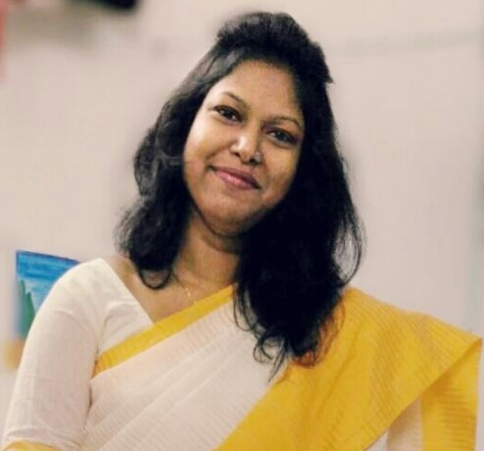

Designation: SACT-I
Affiliation: Dept. of Chemistry, Mrinalini Datta Mahavidyapith, Kolkata 700051
Date of Joining: 13.07.2019
Mobile: +91-9163141075
E-mail: sunanda.dey480@gmail.com

Educational Qualification:
Examination | Board/University/Institute | Year | % of Marks
Class 10 | WBBSE | 2008 | 80.6
Class 12 | WBCHSE | 2010 | 80.2
B.Sc.  (Chemistry Hons.) | University of Calcutta  (Raja Peary Mohan College, Hooghly) | 2013 | 67.2
M.Sc. (Specialisation  in Organic Chemistry) | The University of Burdwan | 2016 | 87.4
Ph.D. | Jadavpur University | 2021 | -

Research Background:
Type of Research | Supervisor | University/Institute | Topic | Duration
Ph.D. | Prof. Chittaranjan Sinha | Department of Chemistry, Jadavpur University | Design, synthesis and characterization of some O, N and/or S donor Schiff- bases for the application in the field of fluorescent sensor | 2017-2021

Research Interest(s): Fluorescent Sensor, Metal Organic Framework
Awards/Achievements:
- Burdwan University Gold Medal, Gourikanta Mukherjee Memorial Gold Medal, Dr. Sumanta Basu Bronz Medal from The University of Burdwan, for securing the highest marks in M.Sc. (Chemistry; 2014-2016).
- Qualified NET (National Eligibility Test), June 2016 and awarded CSIR-JRF fellowship by CSIR-UGC (Govt. of India) (AIR-71, CSIR NET)
- Qualified GATE, 2016 (AIR 591)
Teaching experience:
- State Aided College Teacher (SACT-I), Department of Chemistry, Mrinalini Datta Mahavidyapith, Kolkata (From July 2019 – present)
Award Presentations/Judgements
- Poster Presentation (awarded) at 9th International Science Conference organized by World Science Congress on 28th February-1st March, 2020, Jadavpur University, Kolkata.
- Invited as a Judge at National Science Day Celebration-2021 & National Seminar on “Material Chemistry – Today & Tomorrow”, organized by Journal of the Indian Chemical Society on 28th February & 1st March, 2021.
- Invited as a Judge at 98th Foundation Day Celebration of Indian Chemical Society & National Seminar, organized by Journal of the Indian Chemical Society on 9th May, 2021.

Publications:
- Sunanda Dey, Rakesh Purkait, Chiranjit Patra, Moumita Saha, Sanchaita Mondal, Krishna Das Saha and Chittaranjan Sinha, New J. Chem., 2018, 42, 16297‒16306.
- Rakesh Purkait, Sunanda Dey (equal first author) and Chittaranjan Sinha, New J. Chem., 2018, 42, 16653‒16665.
- Sunanda Dey, Suvendu Maity, Ananya Dasmahapatra, Debprasad Chattopadhyay and Chittaranjan Sinha, ChemistrySelect, 2019, 4, 4472‒4474.
- Sunanda Dey, Rakesh Purkait, Kunal Pal, Kuladip Jana and Chittaranjan Sinha, ACS Omega, 2019, 4, 8451‒8464.
- Sunanda Dey, Kunal Pal, Kuladip Jana and Chittaranjan Sinha, ChemistrySelect, 2019, 4, 7932‒7935.
- Sunanda Dey, Suvendu Maity, Kunal Pal, Kuladip Jana and Chittaranjan Sinha, Dalton Trans., 2019, 48, 17818‒17830.
- Sunanda Dey, Pallab Gayen and Chittaranjan Sinha, J Indian Chem. Soc., 2019, 96, 1279‒1285.
- Sunanda Dey, Sayantan Sil, Basudeb Dutta, Kaushik Naskar, Suvendu Maity, Partha Pratim Ray and Chittaranjan Sinha, ACS Omega, 2019, 4, 19959‒19968.
- Chandana Sen, Sunanda Dey, Chiranjit Patra, Debashis Mallick and Chittaranjan Sinha, Anal. Methods, 2019, 11, 4440‒4449.
- Rakesh Purkait, Arka Dey, Sunanda Dey, Partha Pratim Ray and Chittaranjan Sinha, New J. Chem., 2019, 43, 14979‒14990.
- Sunanda Dey, Chandana Sen and Chittaranjan Sinha, Spectrochim. Acta A, 2020, 225, 117471.
- Sunanda Dey, Rakesh Purkait, Debashis Mallick and Chittaranjan Sinha, ChemistrySelect, 2020, 5, 8274‒8283.
- Basudeb Dutta, Sunanda Dey, Kunal Pal, Sambhunath Bera, Sanobar Naaz, Kuladip Jana, Chittaranjan Sinha and Mohammad Hedayetullah Mir, New J. Chem., 2020, 44, 13163‒13171.
- Sunanda Dey, Suvendu Maity, Rakesh Purkait, Kunal Pal, Prasanta Ghosh, Kuladip Jana and Chittaranjan Sinha, Anal. Methods, 2020, 12, 5485‒5495.
- Sukanya Paul, Sunanda Dey, Kunal Pal, Suvendu maity, Kuladip Jana and Chittanranjan Sinha, ChemistrySelect, 2020, 5, 15233‒15242.
- Sunanda Dey, Pallab Gayen and Chittanranjan Sinha, J Indian Chem. Soc., 2021, 100063.
- Sunanda Dey, Sukanya Paul, Kingshuk Debsharma and Chittaranjan Sinha, Anal. Methods, 2021, 13, 5282‒5292.
- Basudeb Dutta, Baishakhi Pal, Sunanda Dey, Suvendu Maity, Partha Pratim Ray and Mohammad Hedayetullah Mir, Eur. J. Inorg. Chem., 2022, 2022, e202100904.
- Basudeb Dutta, Kingshuk Debsharma, Sunanda Dey (equal first author), Sanobar Naaz, Chittaranjan Sinha and Mohammad Hedayetullah Mir, Adv. Mater. Interfaces, 2022, 9, 2201120.
- Basudeb Dutta, Kingshuk Debsharma, Sunanda Dey (equal first author) and Chittaranjan Sinha, Appl. Organomet. Chem., 2022, e6919.
- Kingshuk Debsharma, Sunanda Dey, Edamana Prasad and Chittaranjan Sinha, J Indian Chem. Soc., 2022, 99, 100671.
- Kingshuk Debsharma, Sunanda Dey (equal first author), Dhananjay Das, Satyajit Halder, Joaquin Ortega-Castro, Sarita Sarkar, Basudeb Dutta, Suvendu Maity, Kuladip Jana, Antonio Frontera, Partha Pratim Ray and Chittaranjan Sinha, CrystEngComm, 2022, Just Accepted.

Sunanda Dey
Date: 08.12.2022

